**The Embassy of France to Australia**

**Australian-French Association for Research and Innovation (AFRAN) Inc.**

**Application Form**

**Pacific Bio-Innovation Hackathon:**

***From Lab to Impact***

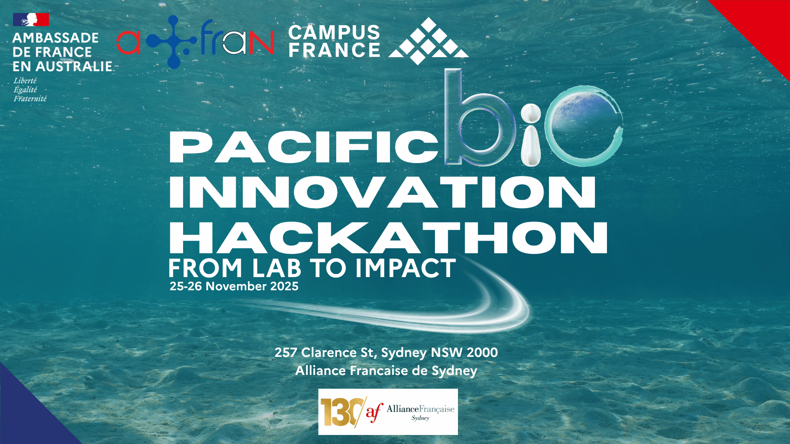

25-26 November 2025 – Alliance Française of Sydney

**All included fields are required. Only completed applications will be examined.   
Please ensure you include all required additional documentation with your application.**

**Closing Date: 27 October 2025**

**1 – PARTICIPANT INFORMATION**

|  |  |
| --- | --- |
| Prefix (Mr, Mrs, Dr, etc.) |  |
| First Name |  |
| Last Name |  |
| Email Address |  |
| Occupation |  |
| Company/Organisation of affiliation |  |
| Work Address |  |
| Work Phone |  |
| English proficiency |  |

**Please also attach a copy of your CV**

**2- INTEREST FOR THE HACKATHON**

|  |  |
| --- | --- |
| Information on your career pathway (PhD stage; industry interest…) |  |
| 100-word motivation letter for this hackathon |  |
| 2 or 3 topics of expertise and interest in order of preference |  |

**3- PARTICIPANT DECLARATION**

I, _______________________, confirm that I have truthfully completed the application form to the best of my knowledge. My CV is also attached.

Signed: Date:

**More information and to apply:**

Please contact/send this form to:

[science.canberra-amba@diplomatie.gouv.fr](mailto:science.canberra-amba@diplomatie.gouv.fr)

+61 (02) 6216 0133