


YOUTH ENGAGEMENT LEADERSHIP PROGRAM

AFRAN Youth Engagement Leaders

Call for Applications 2026

The Embassy of France in Australia is seeking to appoint Youth Engagement Leaders, acting as student ambassadors to collaborate on initiatives that promote bilateral cooperation between France and Australia.
These Leaders have the support and represent the interests of the AFRAN network, Campus France Australia, and France Alumni throughout the year.


AFRAN Network
The Australian - French Association for Research and Innovation (AFRAN) aims to actively promote the development of cooperation between France and Australia in the areas of research and innovation.

Campus France Australia
Campus France Australia is the French public agency in charge of promoting French higher education to Australian students and managing the mobility of students and researchers.

France Alumni

France Alumni is a Campus France online platform designed to unite students who studied in French higher education. It regroups employment opportunities and networking events for Alumni.

The Program
The AFRAN Youth Engagement Program is a program allowing young students, researchers and professionals to engage with French-Australian relationships, promoting key thematics and research and study opportunities in both countries, and across the Pacific and Indian oceans. AFRAN hubs around Australia operate with the contribution of volunteers, creating dynamic links and opportunities for engagement, at all levels. AFRAN keeps its members connected, informed and involved. Members of AFRAN benefit from exclusive news, grants and opportunities available to the Franco-Australian research sector and can also join the different AFRAN scientific communities in Energy, Climate, Digital Sciences, Humanities & Social Sciences, Smart Cities, Bushfires, Agriculture, Health, Space, Manufacturing, or to set up a new one in their field of expertise.
The community is supported by the Embassy of France, France Alumni, the AFRAN network and the Campus France Australia agency. Youth Engagement Leaders, operating as volunteers, assist in events, networking and communication for members and for current or potential students who wish to undertake studies or research in France and/or in Australia. The Youth Engagement Leaders ensure the continued development of the community by promoting student exchanges and academic experiences in the two countries, as students who choose France today will become tomorrow’s alumni.

Role of the Youth Engagement Leaders
The role of the Youth Engagement Leader is to connect the AFRAN activities with university and higher education target communities. The Leaders are responsible for managing the Community in the zone they live in, and showcasing international opportunities and experiences to further promote student mobility between France and Australia.
This volunteer role provides the Community Leaders with invaluable professional and personal development and experience.

Desired profile
The desired profile of the Youth Engagement Leader is as follows:
- The candidate must have at minimum finished second year of university;
- The candidate must be familiar with the higher education and research system in France;
- Some French language experience is desirable for the candidate to better engage with the network;
- Some volunteering experience is useful.

Available Positions



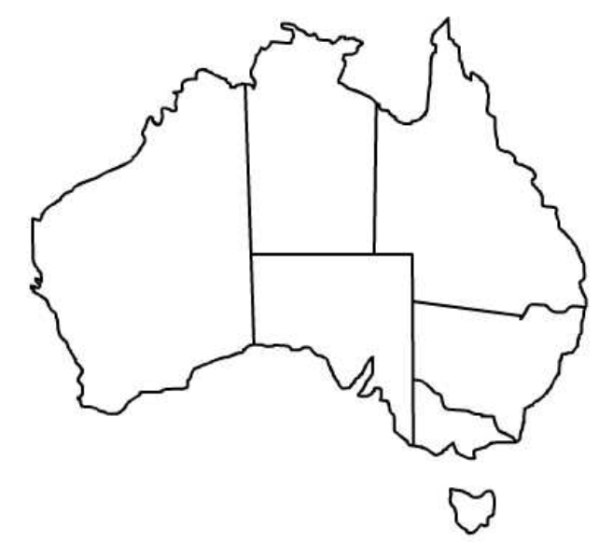
Position available:
(TAS)
Position available:
(SA)
Position available:
(NSW)
Position available:
(QLD)
Position available:
(VIC)
Position available:
(ACT)
Position available:
(WA)
Positions available:
(Pacific)
(Indian Ocean)

Position available:
(France)

Duties and expectations
Communication with the AFRAN members and coordination of events:
- Social media: occasionally create content (articles, photos) on the AFRAN LinkedIn page. Promote any information about events on the France Alumni Network AFRAN group.
- Organise events (panels, coffee catch ups, etc). The events may be organised around topics of interest according to the involvement and interests the members have in the Franco-Australian relationship. Lead the organisation of events (setting dates, booking venues, social media communication and other promotional supports, etc).
- Identify local events that present an opportunity for the AFRAN Community to be involved, and share them to the appropriate channels.
- Coordinate with local French partners: the local Alliance Française will be a potential partner in organising events, as well as the Consulate and any University French or Cultural Clubs.
- Managing the dedicated budget. AFRAN allocates a budget covering the fees related to the organisation and promotion of events (location hire, catering, flyers and other costs). The Leader will not be expected to cover out-of-pocket costs.
Use the unique perspective of the French higher education system to encourage current or potential students to undertake studies or research in France:
- Providing students with access to practical information about living and studying in France where possible.
- Promote and diffuse relevant information published by Campus France Australia on Facebook and by AFRAN on X by sharing posts within their own personal, professional and alumni networks.
- Promote the global France Alumni network for those who are interested in international opportunities, which is hosted via the online platform France Alumni. Grow the France Alumni network by encouraging prospective students to join the Network on their return to Australia.
- Offer to answer questions from peers who are interested in studying, researching or undertaking a professional experience in France.
- Represent AFRAN & Campus France Australia at the annual Exchange Fair Circuit events held on the university campuses in their city.
- Contribute to the annual “French Day on Campus” event when it’s held in their city.
The candidate should be prepared to participate in public events and presentations, plan events, have strong initiative and be able to operate autonomously, manage a budget, while maintaining regular contact with the other Youth Engagement Leaders of other States and the Embassy. The Leaders will be invited to participate in a training and orientation session with the Embassy and AFRAN, which will give information on the strategies of Campus France and AFRAN, and tools which can be used toward the role.

Benefits
There are a number of benefits to this student ambassador role:
- Developing professional and leadership skills;
- Sharing your experience and meeting people;
- Networking opportunities with a broad range of domestic and international contacts;
- Develop public speaking and presentation capabilities;
- Community engagement experience;
- Volunteer experience within a national organisation and international agency;
- Opportunities to develop strategies within an organisation;
- Experience in managing a budget with autonomy within a team;
- Mentorship
This experience would be a valuable addition to a CV, as it demonstrates a communication-based skillset as well as a willingness to give back to the community by providing relevant information and education.
In addition, the Community Leader will benefit from membership with the French Australian Chamber of Commerce and Industry (FACCI), with membership fees covered by the Embassy, and receive exclusive access to their events.

Apply now:
To apply, please send an email to education.canberra-amba@diplomatie.gouv.fr.
Please include a one-page max Word document that outlines why you think you are a good fit for the role, mentioning your current enrolment status and detailing your experience or knowledge of France and the higher education and research system. Please note that as this is not a job application, a CV is helpful but not mandatory, and there is no need to provide a cover letter.
Make sure to include: your best contact information, what city you are applying to represent, and any language proficiency information.
Please send your application or address any further questions to education.canberra-amba@diplomatie.gouv.fr.
The selection process will close on the 26th of November 2025.

